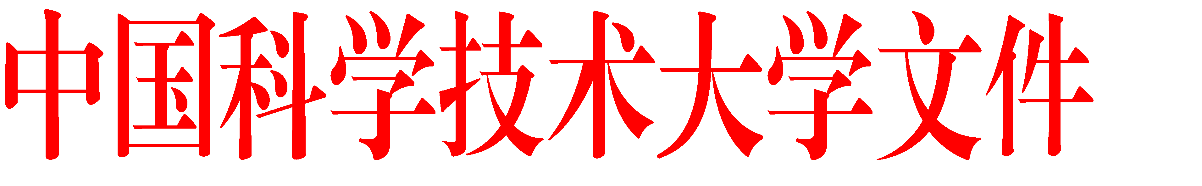
校学位字〔2021〕237号
Document No. 237
Graduate School〔2021〕

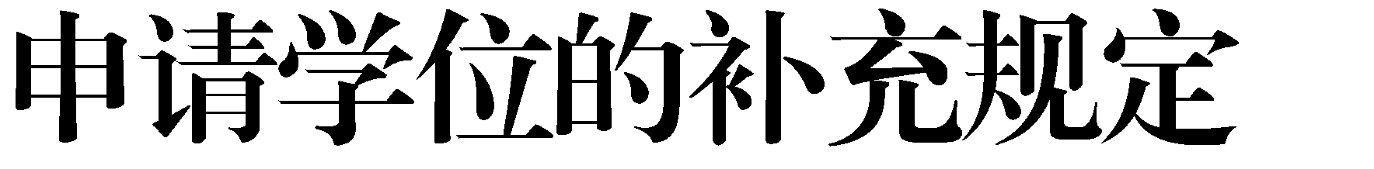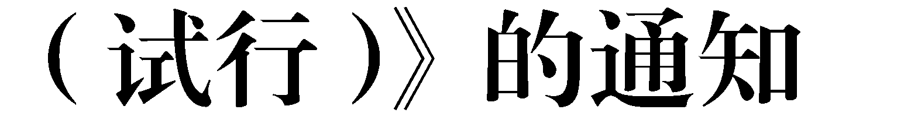
Notice on the Issuance of the "Provisional Regulations for Degree Applications after Defense by Graduate Students at University of Science and Technology of China”
各有关单位：
为进一步保障学位论文质量，完善学位授予流程，结合我校实际，学校研究制定了《中国科学技术大学关于研究生答辩后申请学位的补充规定（试行）》，经2021年12月7日校学位委员会工作会议审议通过，现予以印发施行。
特此通知。

To All Schools and Institutes:

In order to further ensure the quality of theses and improve the degree conferral process, the “Provisional Regulations for Degree Applications after Defense by Graduate Students at University of Science and Technology of China” has been formulated. These regulations were reviewed and approved at the University Degree Committee meeting on December 7th, 2021. They are hereby issued and implemented.

This is to formally notify all relevant schools and institutes accordingly.

University of Science and Technology of China
Dec. 28th, 2021

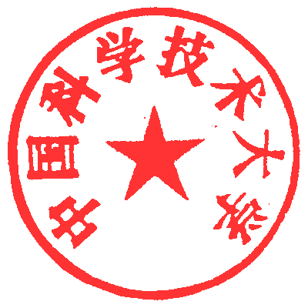
中国科学
技术大学

2021
年
12
月
28
日

(Provisional) Regulations for Degree Applications after Defense by Graduate Students at University of Science and Technology of China

为进一步保障研究生学位论文质量，完善学位授予流程，结合学校实际，对研究生通过学位论文答辩后申请学位作以下补充规定。
In order to further enhance the quality of graduate theses and refine the degree conferral procedures, the following supplementary regulations are hereby formulated for graduate students applying for a degree after successfully passing their thesis defense:

一、博士研究生和学术学位硕士研究生规定
1: Regulations for Doctoral and Academic Master's Degree Graduate Students
1.研究生须在自学位论文答辩通过之日起2年内，按照《中国科学技术大学硕士、博士学位授予实施细则》及各学科成果要求，提交学位申请材料；2年内未提交学位申请材料，视为自动放弃学位申请资格；超过2年不再受理其学位申请。
1) Graduate students must submit their degree application documents within 2 years from the date of successful thesis defense, in accordance with the "Guidelines for the Implementation of Master's and Doctoral Degrees" and the specific requirements of their respective disciplines. Failure to submit the degree application materials within this 2-year period will be deemed as an automatic waiver of the eligibility for a degree application. Degree applications submitted more than 2 years after the successful thesis defense will not be accepted.
2.研究生在提交学位申请材料时，若与学位论文答辩通过时间间隔超过1年，须由学院或学科点组织不少于3名专家对其发表的学术成果与学位论文的相关性进行审核认定（附表）。
2) A panel of at least three experts are appointed by the school or college to review and verify the relevance between academic achievements and thesis (see the attached form), when graduate students submit their degree application documents more than one year after they passed the thesis defense.

3.2018年11月5日之前通过学位论文答辩的研究生，须在
2022年12月31日前提交学位申请材料，逾期不再受理学位申请。
3) Graduate students, who passed their thesis defense before November 5th, 2018, must submit their degree application documents before December 31st, 2022. Applications for degrees will no longer be accepted after this date.
4.2018年11月5日至2020年12月31日之间通过学位论文答辩且答辩时未超过学校规定最长学习年限的研究生，须在2022 年12月31日前提交学位申请材料，逾期不再受理学位申请。
4) Graduate students who successfully defended their thesis between November 5th, 2018, and December 31st, 2020, and who are still in the eligible study period stipulated by the university at the time of defense, must submit their degree application documents before December 31st, 2022. Applications for degrees will no longer be accepted after this date.
5.2020年12月31日之后通过学位论文答辩且答辩时未超过学校规定最长学习年限的研究生，须在自学位论文答辩通过之日起2年内提交学位申请材料，逾期不再受理学位申请。
5) Graduate students, who successfully defended their thesis after November 31st, 2020, and still in the eligible study period stipulated by the university at the time of defense, should submit their degree application documents within two years from the date of defense. Applications for degrees will no longer be accepted after this date.
二、专业学位硕士研究生规定
研究生须在自学位论文答辩通过之日起2年内且自取得学籍 5年内提交学位申请材料。答辩后2年内或自取得学籍5年内未提交学位申请材料，视为自动放弃学位申请资格，不再受理其学位申请。
2: Regulations for Professional Master's Degree
Master students are required to submit their degree application documents within two years from the date of passing their thesis defense and within five years from the date of their registration. Failure to submit the degree application documents within the stipulated periods will be deemed as an automatic waiver of the eligibility for degree application, and their degree applications will no longer be accepted.

三、其他事项
1.学位申请材料提交后，学校将在最近一次学位评定分委员会和校学位评定委员会讨论审核，在召开学位评定分委员会前可以补充完善学位申请相关材料。
3 Others
1) After the submission of degree application materials, the university will conduct discussion and review at the most upcoming meeting of the degree evaluation sub-committee and the university degree evaluation committee. Relevant materials for degree application can be supplemented and improved before the convening of the sub-committee for degree evaluation.

2.本补充规定由校学位办公室负责解释，自印发之日起施行。
2) These supplementary regulations shall be interpreted by the University Degree Office, and takes effect from the date of issuance.

附表

（若申请学位时通过答辩已超过 1 年，须填写此表，扫描成 PDF 上传）
院 系 |  |  |  |  |  |  | 学 号
姓 名 |  |  | 导 师 |  |  |  | 答辩时间
学位论文题目
学术成果 1 |  | 题 目
 |  | 发表期刊
 |  | 发表/录用时间
学术成果 2 |  | 题 目
 |  | 发表期刊
 |  | 发表/录用时间
学术成果 3 |  | 题 目
 |  | 发表期刊
 |  | 发表/录用时间
专家组意见（请对学位论文与学术成果相关性作出审核）：

专家 1 |  |  |  | 专家 2 |  |  | 专家 3
专家组成员签名：

学位论文与学术成果相关性审核表
Review Form for Thesis and Academic Achievements Relevance
（若申请学位时答辩时间已超过一年，须填写此表，扫描成PDF上传）
(For those who apply for the degree more than one year after the thesis defense to fill in the form, scan it as a PDF and upload it in the system)
院 系  school |  |  |  |  |  |  |  |  | 学 号  Student ID
姓 名  Name |  |  |  |  | 导 师  supervisor |  |  |  | 答辩时间  Defense time
学位论文题目
Thesis title
学术成果1  Academic achievement 1 |  | 题 目  Title
发表期刊
Journal
发表/录用时间
Publication / acceptance time
与学位论文哪些章节相关（明确章节题目）
Chapters to which it is relevant ( with the chapter titles)
学术成果2  Academic achievement 2 |  | 题 目  Title
发表期刊
Journal
发表/录用时间
Publication / acceptance time
与学位论文哪些章节相关（明确章节题目）
Chapters to which it is relevant ( with the chapter titles)
学术成果3  Academic achievement 3 |  | 题 目  Title
发表期刊
Journal
发表/录用时间
Publication / acceptance time
 |  | 与学位论文哪些章节相关（明确章节题目）Chapters to which it is relevant ( with the chapter title)
专家组意见（请审核以上相关性说明是否属实，并对学术成果与学位论文整体相关性做出审核说明）：
Opinions of the Expert Group (Please review whether the above relevance is true, and provide a review on the overall relevance between academic achievements and the degree thesis)
专家1  Expert 1 |  |  |  | 专家2  Expert 2 |  |  |  |  | 专家3  Expert 3
专家组成员签名：
Signatures of all experts:

日期：
Date:

中国科学技术大学党政办公室

2021
年
12
月
28
日印发

